Children’s event with author and illustrator Sam Lloyd
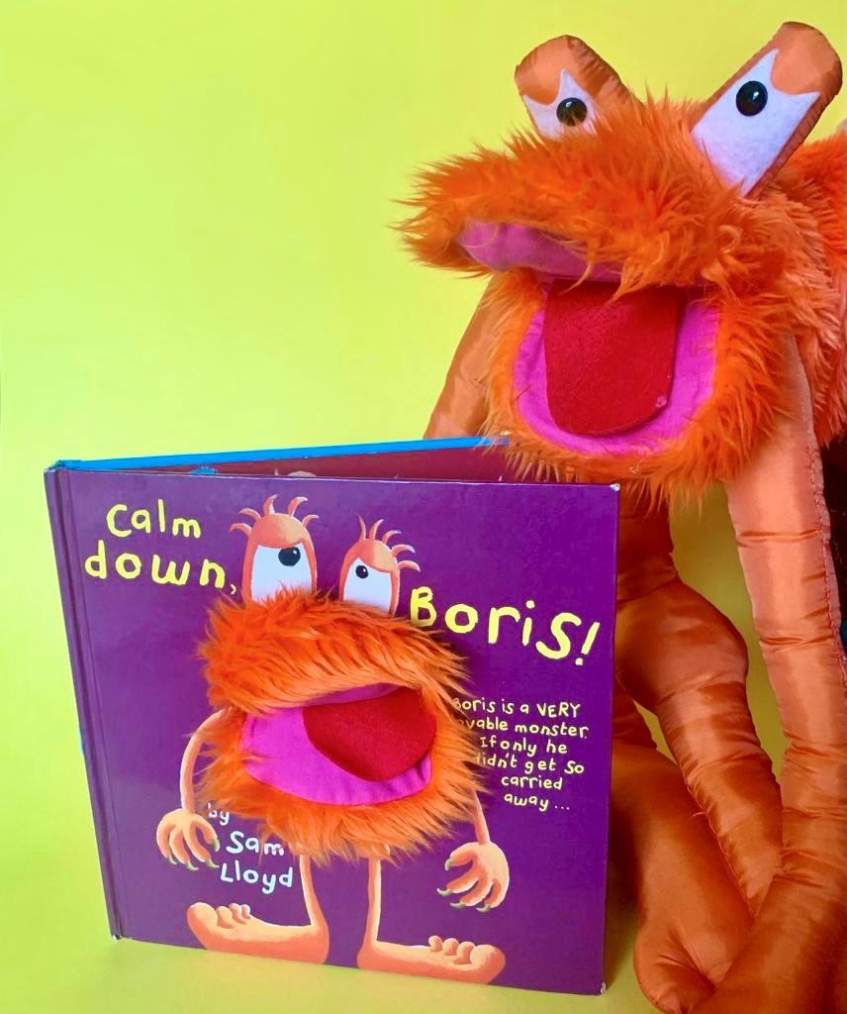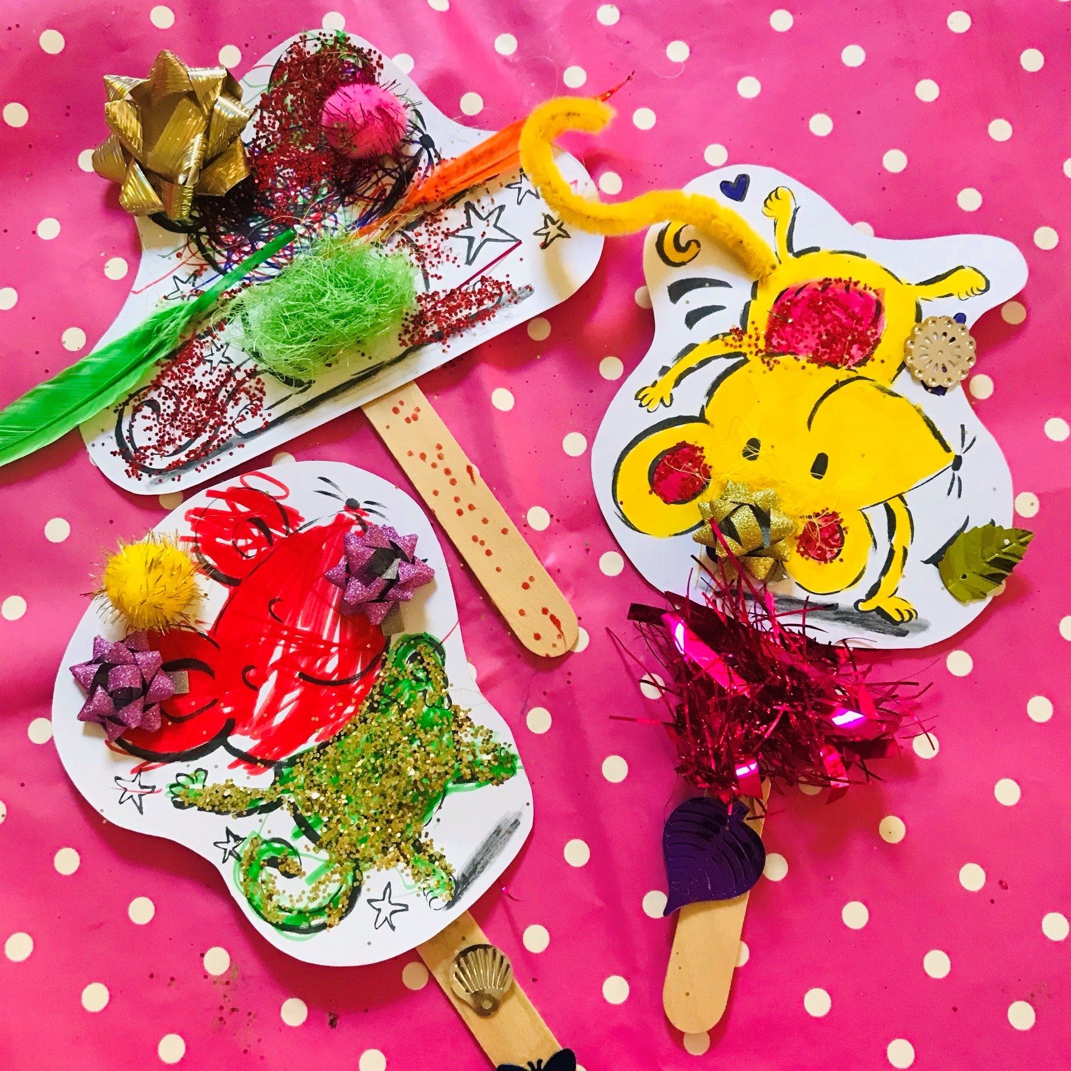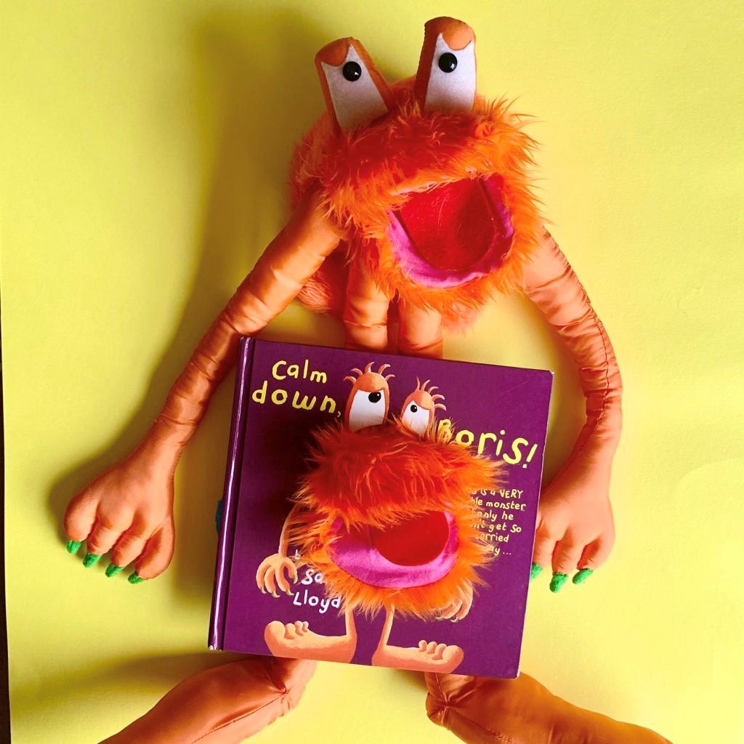

Come along to meet Boris and his friends, listen to some stories, sing some songs…and even make your own mini monster!

Suitable for children aged 2-7

Pre-booking is essential.
Please speak with staff to reserve a place.

Parents and carers must remain with their child during this activity.

Saturday 2nd March
10.00-11.00am
Midhurst Library
The Grange, Bepton Road
GU29 9HD
01730 716671
Midhurst Library, The Gra

The Grange

