The Friends of St Mary’s Church
Annual Meeting and Talk.
The Friends of St Mary’s, which exists for the repair, decoration and improvement of the church fabric, will be holding their brief annual meeting on
Friday 12th November in the Church at 7.30pm

After the brief formalities Rev. Dr. David Crook and Debbie Wright will present:
A History of St Mary’s Church from its origins,
through rebuilding 150 years ago,
to the present day.
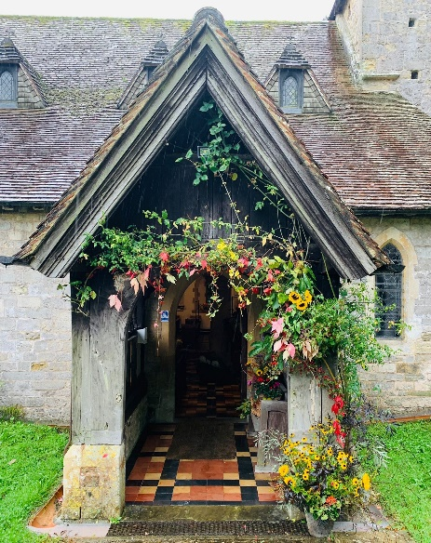
Members who signed up in 2020 or 2021
are invited to attend for free.
Non-members are very welcome for a small donation of £5 on the door,
to include a free glass of wine.

We always welcome new members.
Subscriptions are £8 per single person or £12 per couple.

A short history of the church by Rev David Crook and Deborah Wright
will be on sale after the meeting.

