­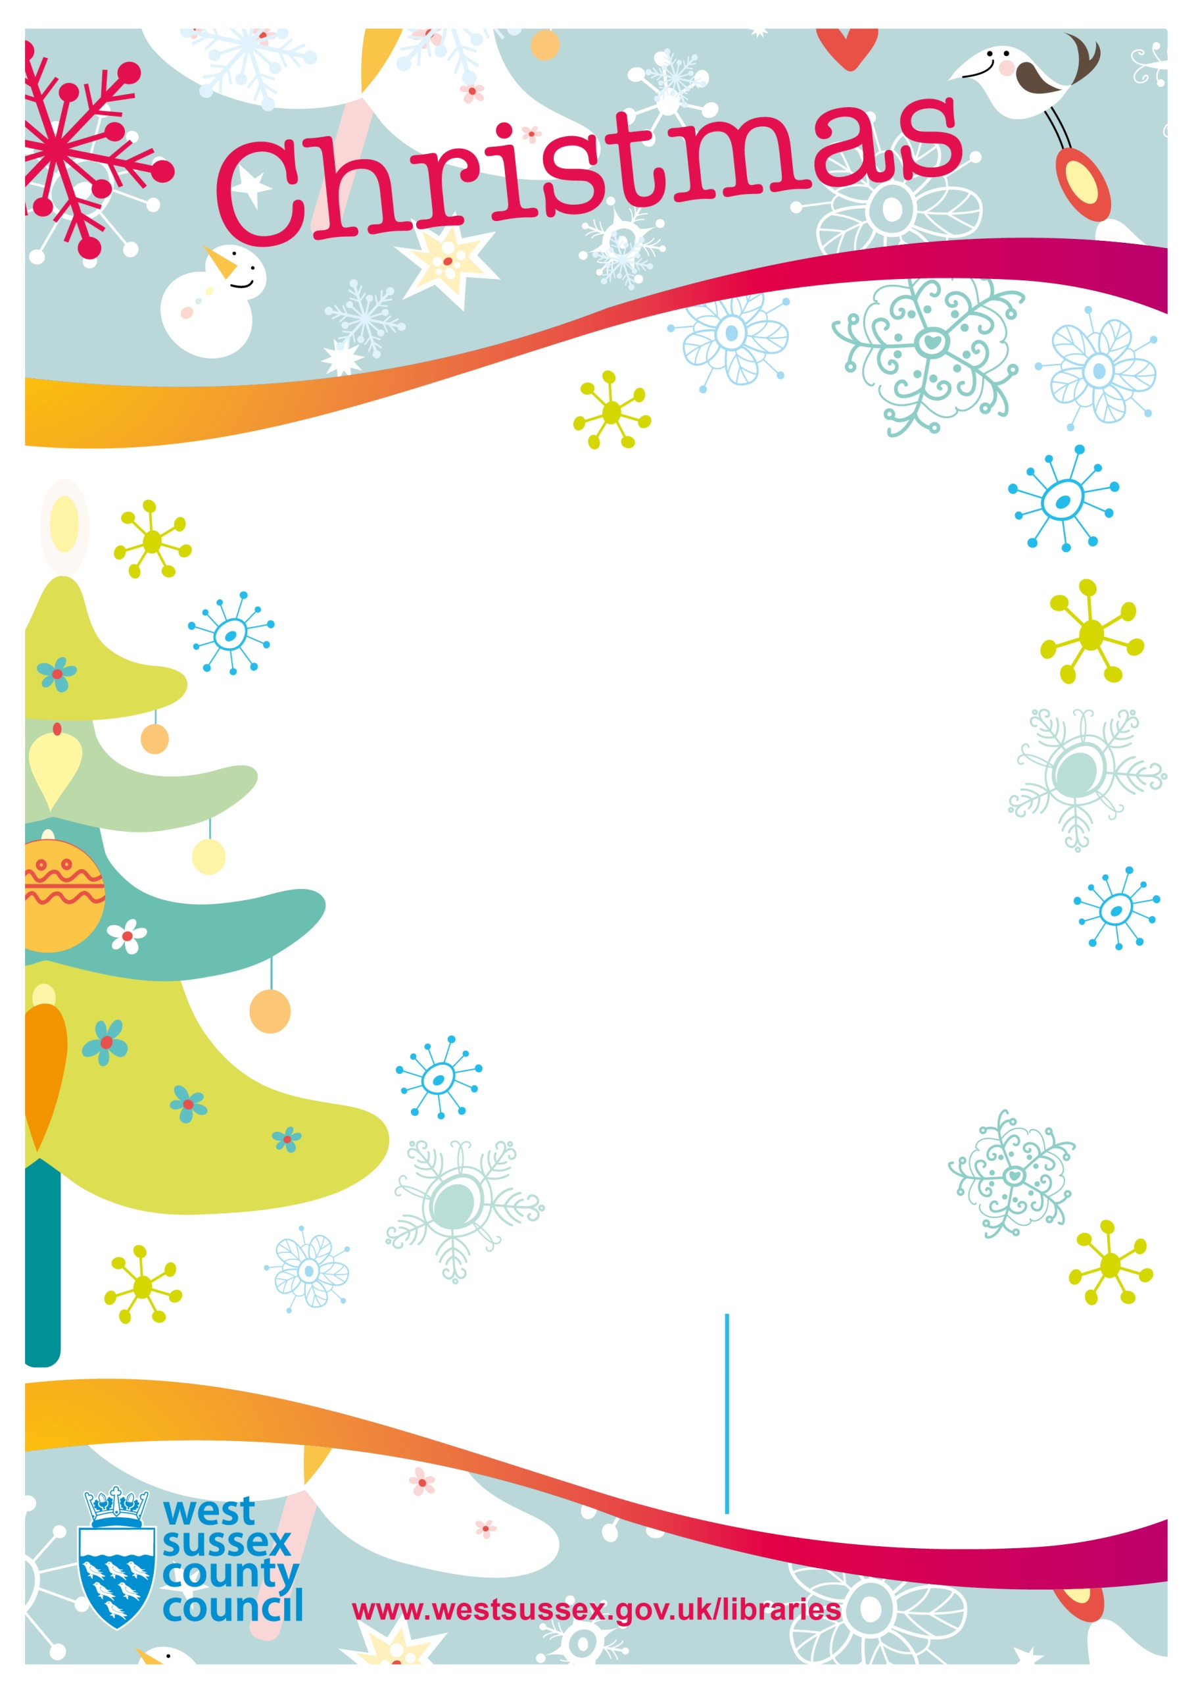

**Chichester Library**

Tower Street

PO19 1QJ

01243 777351

Parents and carers are asked to remain

with their child during this activity

**Christmas Storytime**

**Chichester Library**

**Saturday 23rd December**

**11.00-11.30am**

Join us for Christmas stories and songs and also meet our special guest.

Come in fancy dress if you would like to!