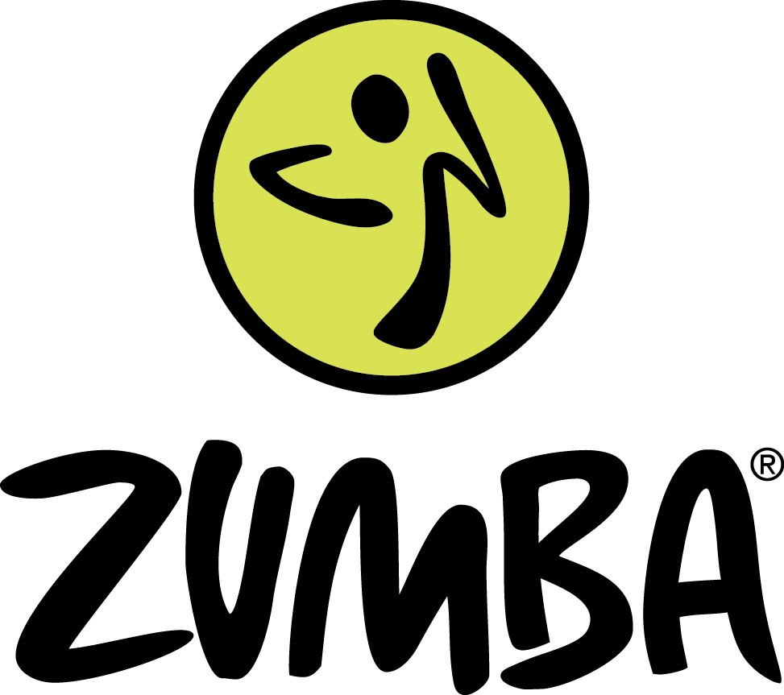
With Kerri Chipper

Come and join a Zumba Fundraiser.
Saturday 25th November 9.30am – 10.30am
At the Village Hall - £5.00 per person
No children under 14 please.
Come and join a fun workout and raise money for the new Community Shop and Playground projects.

