Maggie’s Hut Bed and Breakfast,
Fittleworth

Get away from it all…

Maggie’s Hut is a cosy shepherd’s hut set in a tranquil garden in the pretty downland village of Fittleworth. It has a comfortable double bed and a woodburning stove. You will have all the wood and kindling you need to keep it warm and cosy. There are tea and coffee making facilities, a toaster, crockery and utensils. You can enjoy our very own delicious ‘Maggie’s Blend’ coffee, roasted by our neighbours at ‘The Honeybee Coffee Roastery’. In the morning, a basket of breakfast goodies is delivered to your door. There is a private outdoor (hot) shower next to the hut as well as an eco composting toilet, known as the ‘Bamboo Loo’! It is a stone’s throw from the Swan Inn, a beautiful 15th century coaching inn, where you can enjoy freshly cooked meals and local ales.

From £70 per night B&B
(2 people)

A separate camping cabin is available for up to 2 people. Please enquire.

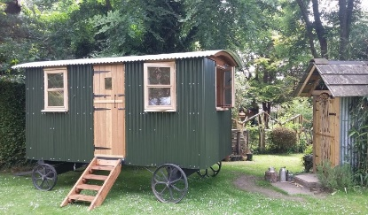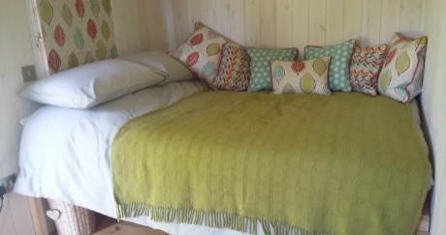
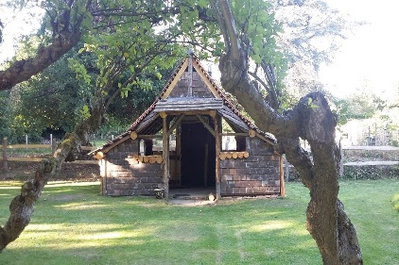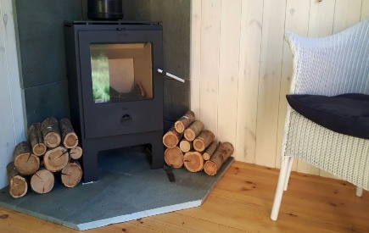

Tel: 01798 865307 / 07879 262266

Email:
maggieshut@btinternet.com

