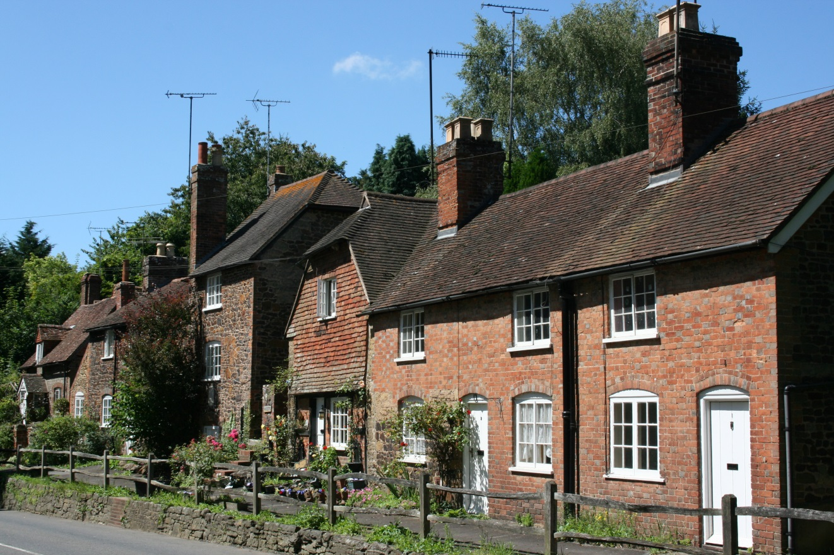

Welcome to Fittleworth

Useful information for new residents

Also see the village website
www.fittleworth-pc.org.uk

We welcome you to this pretty West Sussex village with its beautiful setting, spectacular views, friendly residents and caring community.

This leaflet is intended to provide you with an overview of local facilities and activities to help you become part of the local community. Further details of other regular activities and local events can be found in the Village Magazine; your local distributor will have delivered this letter and we hope you will enjoy your free copy of the magazine. Please let your distributor know if you would like a monthly copy of the magazine.

Medical information:
There are large medical centres in both the neighbouring towns:
Pulborough Medical Group 01798 872815 (by Tesco)
Petworth Surgery 01798 342248 (Grove Street – out of town, past the Library).
The nearest Hospital is St Richard’s Hospital in Chichester. It has A&E facilities.

Police:
- Emergencies 999
- Local police (non-urgent) 101
- Crimestoppers (anonymous reporting of problems) 0800 555 111
- Operation Crackdown (anti-social driving, abandoned vehicles) 01243 642222

Churches locally:

Anglican St Mary the Virgin, Fittleworth
St Mary the Virgin, Stopham
Rev’d Colin Datchler B.Th (Oxon)
01798 865473
The Friends of St Mary’s Fittleworth; a non
religious group who raise money for the
church building, mainly through local
social events. Contact 01798 865563
Roman Catholic Sacred Heart Church, Petworth
St Anthony & St George, Duncton
Fr Peter Newsam 01798 342169
Free Church Fittleworth Evangelical Church, School La.
Elders; Tim Burr 01798 831078
David Cresswell 01798 344898
United Reformed Golden Square, Petworth
Contact secretary on 01798 343102

Garage services:
Tripp Hill Garage south of the village offers car sales, repairs and breakdown services. The nearest petrol filling stations are in Pulborough (north on the A29) and towards Bury (south on the A29).

Fittleworth and District Association
Contact 07717 293710

Fittleworth and District Horticultural Society:
Sally Tanner 01798 865175 or visit www.fittleworthhorticulturalsociety.co.uk

Libraries:
The mobile library visits the village fortnightly; please phone 01243 642111 to check schedules, or email
www.westsussex.gov.uk/leisure/libraries.aspx
Petworth (Rosemary Lane) | both open Mon / Tues / Wed pm
Pulborough (Swan View) | and Thurs / Fri / Sat am
Chichester (Tower Street) open all day

NADFAS (National Association of Decorative and Fine Arts Societies):
West Sussex Group:- 1st Tuesday of month. Contact 01903411086
South Downs Group:- 1st Wednesday of month. Contact 01403 783359
Both groups meet in Fittleworth Village Hall.

Parish Council:
Meets at 7pm on the 3rd Monday of each month (except August) in the Sports & Social Club (the Pavilion) next to the Village Hall; villagers are welcome to attend.

Public Houses:
The Swan Inn, Fittleworth 01798 865429
The White Hart, Stopham 01798 873321
The Welldiggers Arms, Low Heath 01798 344288

Public transport:
Bus No 1 (operated by Stagecoach; 0871 2002233) runs along the Fleet and links Fittleworth with Midhurst and Worthing (hourly, Mon – Sat, 2 hourly Sundays).
Petworth and Chichester are linked by the 99 route, operated by Compass (this is a flexible route operating Mon – Sat; 01903 264776 for details). Information on bus timetables in general can be obtained from http://www.westsussex.gov.uk
Pulborough railway station offers services to London and the south coast. Train times from http://www.nationalrail.co.uk/ or 08457 484950.

School:
Fittleworth C.E. Village School. Contact 01798 865419.
www.fittleworthschool.org.uk

Sports & Social Club:
Bowls, Cricket, Croquet, Darts, Football, Stoolball are all available – see back page of the Village Magazine or the village website.

Take-away restaurants:
Fish and chips available in Petworth (Pound St) and in Pulborough (opposite the station). Chinese and Indian take-aways available in both towns.

Village Hall:
Venue for most village activities. Contact the booking officer and caretaker Len Cole on 01798 865956 or email lennyboot@hotmail.co.uk

Youngsters:
Beavers, Brownies, Cub Scouts, Scouts and Guides, Junior and Senior Crusaders are all active locally; see back page of the Village Magazine.

We hope that you will be very happy in your new home.

