The Friends of St Mary's Church
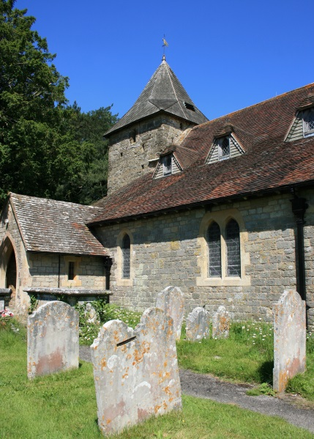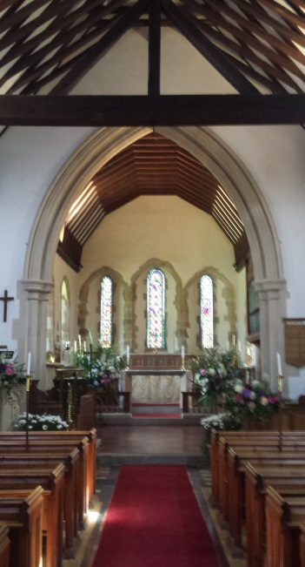

If you love beautiful old buildings and would like to be involved in helping to preserve one of Fittleworth's most historic landmarks, then becoming a Friend of St Mary's Church, Fittleworth, may be for you.
It is not necessary to be a church member, to have a particular faith, or to participate in church activities to be a Friend - just a wish to help preserve, repair and improve a building that has been part of the village for over 800 years. The Friends was formed in 2002, for anyone who would like to combine raising money for the repair and restoration of this old building, with a range of social events.
Through the Fabric Fund, the Friends of St Mary's has contributed money for the repair of the ceiling, the chancel windows, relaying the floor tiles and work on the ringing room of the church as well as other projects.
We are always grateful for donations, but we take our social activities seriously too! We have held race nights, an Elgar evening (Elgar had local links with Fittleworth and this church), jazz nights, a barn dance, Secrets and Spies evening, a Fascinating Fittleworth evening (covering many aspects of the village) and a village trades and crafts exhibition - as well as other events.
Our annual subscription of £8.00 for one person, or £12.00 for two people at the same address gives members details and reduced price tickets for events, a free social event once a year with the AGM, as well as the enjoyment of other fundraising events. Look out for our articles and photos in the Village Magazine and on this website!
Please phone 01798 86556301798 865563 for information
The Friends welcome new members and new ideas!
