The Friends of St Mary the Virgin, Fittleworth
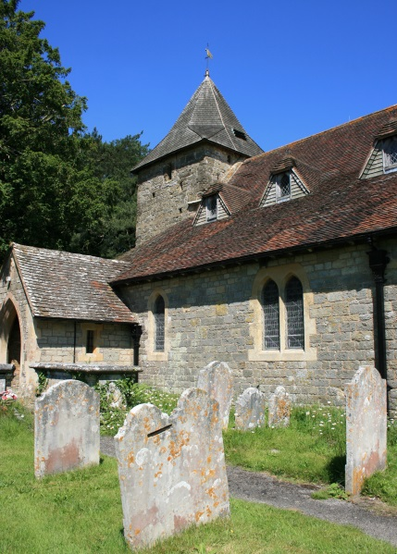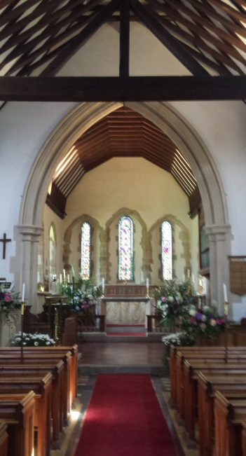

If you love beautiful old buildings and would like to be involved in helping to preserve one of Fittleworth's most historic landmarks, then becoming a Friend of St Mary's Church, Fittleworth, may be for you.
The Friends was formed in 2002, to help preserve, repair and improve a building that has been part of the village for over 800 years. The church was in Fittleworth at the time of the signing of the Magna Carta. It was partly demolished and rebuilt in the 1800s, but remains a peaceful, historic building for our community; sadly the gallery and box pews were destroyed, but the tower and chancel have an English Heritage Grade l listing. Anyone who would like to combine raising money for the repair, restoration and improvement of this old building, with a range of social events open to the whole community, is welcome to join us; it is not necessary to participate in church activities to be a Friend and members are of all faiths or none.
The Friends committee liaises with the church PCC, about building ‘needs’. Through the Fabric Fund, the Friends of St Mary's has contributed money for the desperately-needed repairs to the church ceiling and other repairs including chancel windows, ringing room, lightning conductor, relaying the floor tiles and recently more work on the tower. Projects that improve the church and enable community events, including fundraising, have been contributions to the installation of the hearing loop and audio visual equipment, re-fitting the vestry kitchen, and providing a lantern by the path and Church Lane.
We are always grateful for donations, but we take our social activities seriously too! We have held race nights, an Elgar evening (Elgar had local links with Fittleworth and this church), jazz nights, a barn dance, Secrets and Spies evening, a Fascinating Fittleworth evening (covering many aspects of the village), the launch of the book ‘Fittleworth – a Time of Change 1895-1916,’ an Art and Artists in Sussex evening, a geology talk and walk, Murder Mysteries and a Village Trades and Crafts exhibition - as well as other events and annual talks.
Our annual subscription of £8.00 for one person, or £12.00 for two people at the same address gives members details and reduced price tickets for events, a free social event once a year with the AGM, as well as the enjoyment of other fundraising events. Look out for our articles and photos in the Village Magazine and on this website!
Please phone 01798 865563 or 865202 for information
The Friends welcome new members and new ideas!
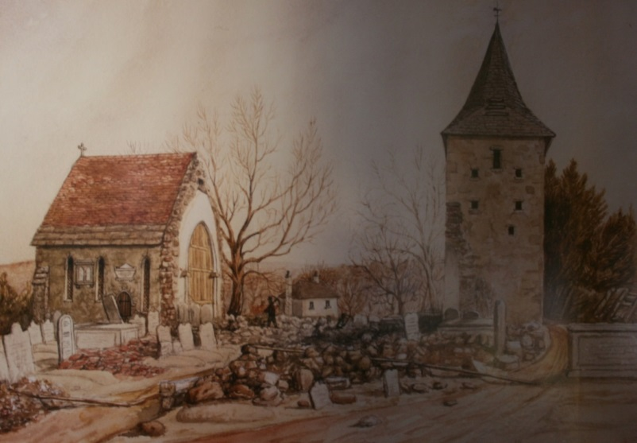
The chancel and tower remaining, during Victorian ‘improvement’

